**Namaste React Notes**

**Lecture 1- Inception**

**Hello World Program by using HTML**

<!DOCTYPE html>

<html lang="en">

<head>

  <meta charset="UTF-8">

  <meta name="viewport" content="width=device-width, initial-scale=1.0">

  <title>Namaste React</title>

</head>

<body>

  <div id="root">

    <h1>Hello World using HTML</h1>

  </div>

</body>

</html>

**Hello World Program by using Javascript**

<!DOCTYPE html>

<html lang="en">

<head>

  <meta charset="UTF-8">

  <meta name="viewport" content="width=device-width, initial-scale=1.0">

  <title>Namaste React</title>

</head>

<body>

  <div id="root">

  </div>

  <script>

    const heading = document.createElement("h1");

    heading.innerHTML = "Hello World from JavaScript"

    const root = document.getElementById("root")

    root.appendChild(heading)

  </script>

</body>

</html>

**Injecting React into Html file using CDN(Content Delivery Network)**

<!DOCTYPE html>

<html lang="en">

<head>

  <meta charset="UTF-8">

  <meta name="viewport" content="width=device-width, initial-scale=1.0">

  <title>Namaste React</title>

</head>

<body>

  <div id="root">

  </div>

  <script crossorigin src="https://unpkg.com/react@18/umd/react.development.js"></script>

  <script crossorigin src="https://unpkg.com/react-dom@18/umd/react-dom.development.js"></script>

</body>

</html>

**Hello World Program using React**

<!DOCTYPE html>

<html lang="en">

<head>

  <meta charset="UTF-8">

  <meta name="viewport" content="width=device-width, initial-scale=1.0">

  <title>Namaste React</title>

</head>

<body>

  <div id="root">

  </div>

  <script crossorigin src="https://unpkg.com/react@18/umd/react.development.js"></script>

  <script crossorigin src="https://unpkg.com/react-dom@18/umd/react-dom.development.js"></script>

  <script>

    const heading = React.createElement("h1", {}, "Hello World from React")

    const root = ReactDOM.createRoot(document.getElementById("root"))

    root.render(heading)

  </script>

</body>

</html>

**Separating the JavaScript Code, CSS and HTML into separate files**

**index.html**

<!DOCTYPE html>

<html lang="en">

<head>

  <meta charset="UTF-8">

  <meta name="viewport" content="width=device-width, initial-scale=1.0">

  <link rel="stylesheet" href="index.css">

  <title>Namaste React</title>

</head>

<body>

  <div id="root">

  </div>

  <script crossorigin src="https://unpkg.com/react@18/umd/react.development.js"></script>

  <script crossorigin src="https://unpkg.com/react-dom@18/umd/react-dom.development.js"></script>

  <script src="App.js"></script>

</body>

</html>

**App.js**

const heading = React.createElement(

  "h1",

  { id: "heading", "data-testid": "heading", testid: "heading" },

  "Hello World from React"

);

const root = ReactDOM.createRoot(document.getElementById("root"));

root.render(heading);

**index.css**

#root {

  background-color: aqua;

}

**Output:**



**If we console.log(heading) in App.js**

const heading = React.createElement(

  "h1",

  { id: "heading", "data-testid": "heading", testid: "heading" },

  "Hello World from React"

);

console.log(heading)

const root = ReactDOM.createRoot(document.getElementById("root"));

root.render(heading);

**Output:**

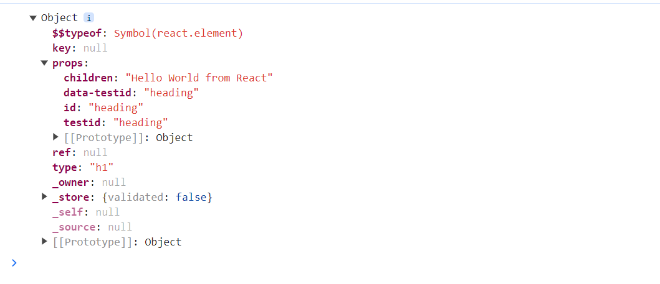

**Creating Nested Elements in React**

**Trying to create**

  <div id="parent">

    <div id="child">

      <h1 id="inner-child">Hello World!</h1>

    </div>

  </div>

const parent = React.createElement(

  "div",

  { id: "parent" },

  React.createElement(

    "div",

    { id: "child" },

    React.createElement("h1", { id: "inner-child" }, "Hello World!")

  )

);

const root = ReactDOM.createRoot(document.getElementById("root"));

root.render(parent);

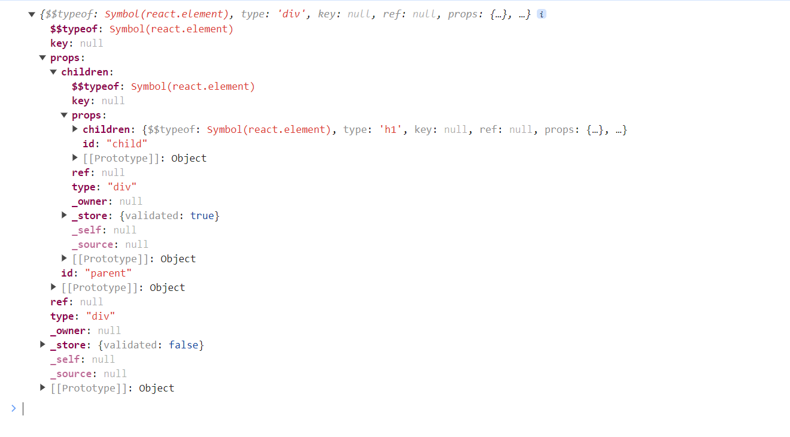

Notice the children in the above example

**Creating Siblings in React**

  <div id="parent">

    <div id="child">

      <h1 id="inner-child1">H1 Tag</h1>

      <h2 id="inner-child2">H2 Tag</h2>

    </div>

  </div>

const parent = React.createElement(

  "div",

  { id: "parent" },

  React.createElement(

    "div",

    { id: "child" },

    [React.createElement("h1", { id: "inner-child1", key:"1" }, "H1 Tag"),

    React.createElement("h2", { id: "inner-child2", key:"2" }, "H2 Tag")]

  )

);

console.log(parent);

const root = ReactDOM.createRoot(document.getElementById("root"));

root.render(parent);

**Siblings are passed inside an Array**



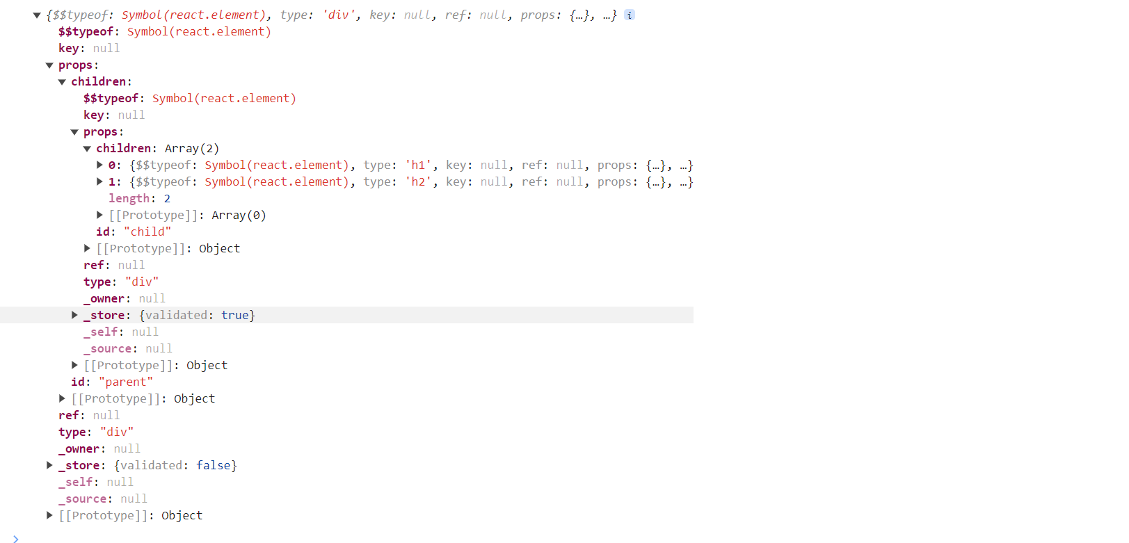

**It becomes extremely complex to write React Code like this. So, there came the need for JSX (HTML Like syntax inside Javascript)**

**Lecture-02 Igniting Our App**

**npm** is a package manager for the JavaScript programming language maintained by npm, Inc. npm is the default package manager for the JavaScript runtime environment Node.js and is included as a recommended feature in the Node.js installer.

**Project Scaffolding Steps:**

1. **npm init (Creates package.json)**

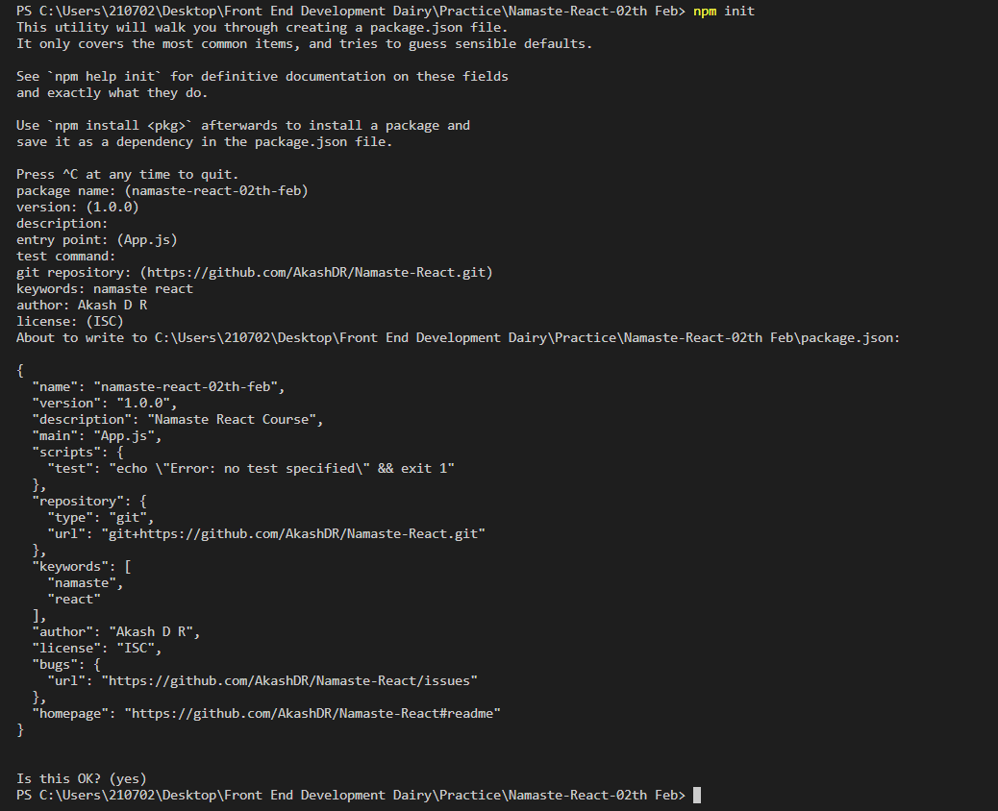

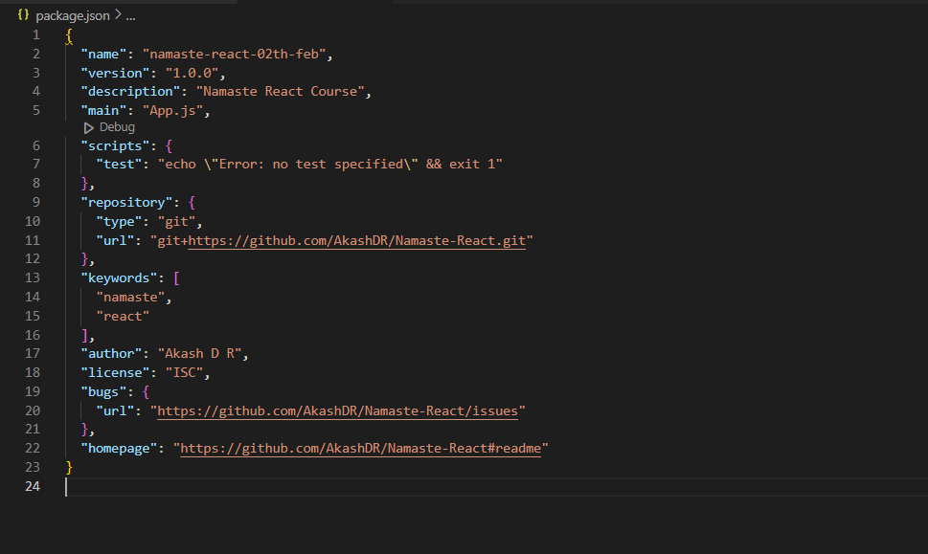

Package.json is configuration for npm. It contains details of all the packages/libraries the project has like version, package Name etc.

1. **npm install -D parcel (Installs parcel as Developer Dependency)**

The above command adds **package-lock.json file**, node modules folder, parcel package and other dependency package of the parcel

A bundler helps in creating production ready apps. Example of bundlers include webpack, vite, parcel etc.

**Difference between Dev Dependency and Normal Dependency:**

<https://www.geeksforgeeks.org/difference-between-dependencies-devdependencies-and-peerdependencies/>

While installing parcel or any bundler, if you get this error

**npm ERR! 404 Not Found - GET** [**https://registry.npmjs.org/create-react-app/webpack**](https://registry.npmjs.org/create-react-app/webpack)

then we have to set the registry. Only if we set the registry, then npm would download the packages from that registry. Steps to resolve the issue are listed below

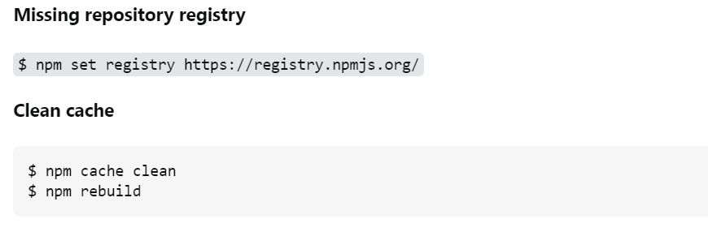

**Difference between Caret and Tilde**

Caret(^) consider only patch and minor version update automatically. Caret(^) is less safer than Tilde(~) for production app. because here minor feature will also update automatically .

<https://www.geeksforgeeks.org/difference-between-tilde-and-caret-in-package-json/>

<https://www.linkedin.com/pulse/difference-bw-tilde-notation-caret-alok-tiwari/>

1. **cat > .gitignore**

Create .gitignore file by using above command and add all the files which should not be committed

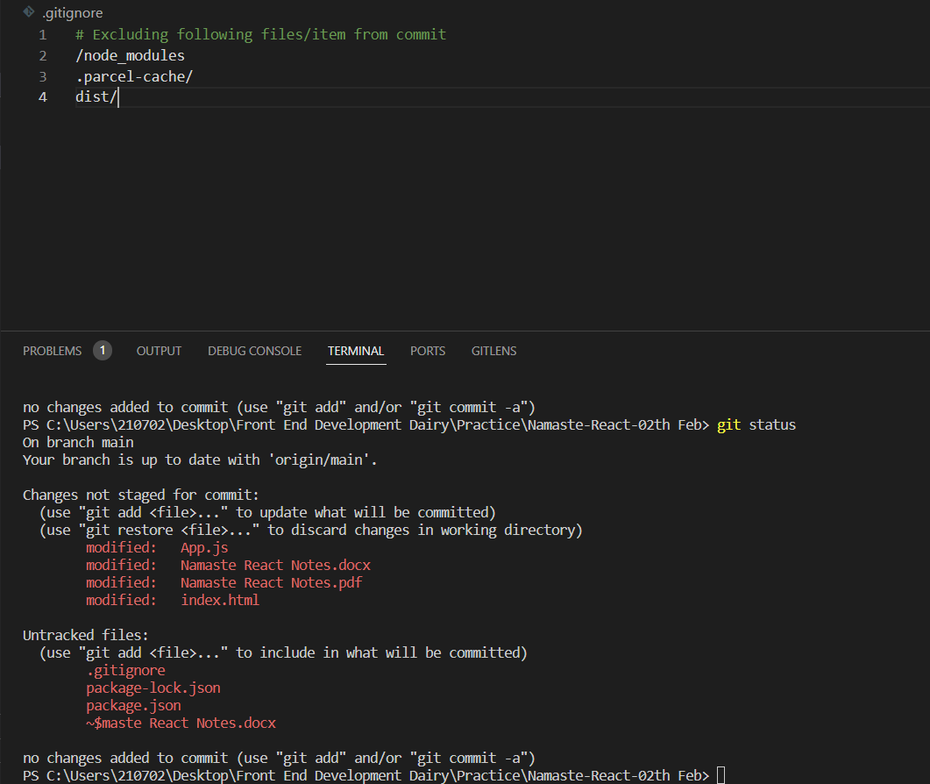

**How to create .gitignore file**

<https://www.youtube.com/watch?v=ErJyWO8TGoM&ab_channel=codebasics>

1. **npx create index.html**

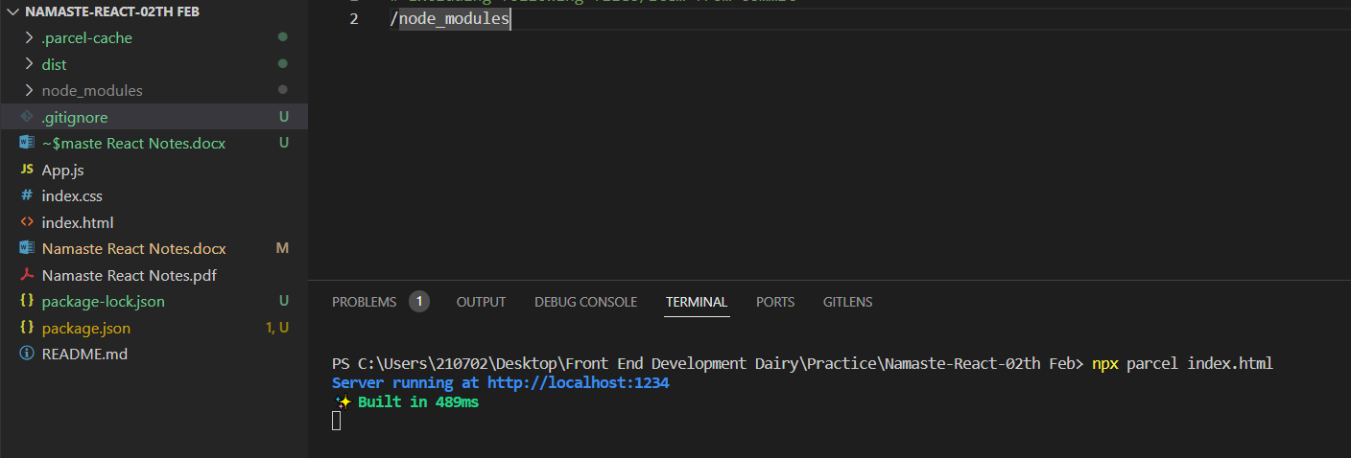

Start/Index the application using the above command. Notice that it has created .parcel-cache and dist folder inside the project. Project starts on port 1234

**npx** is used to execute the package.

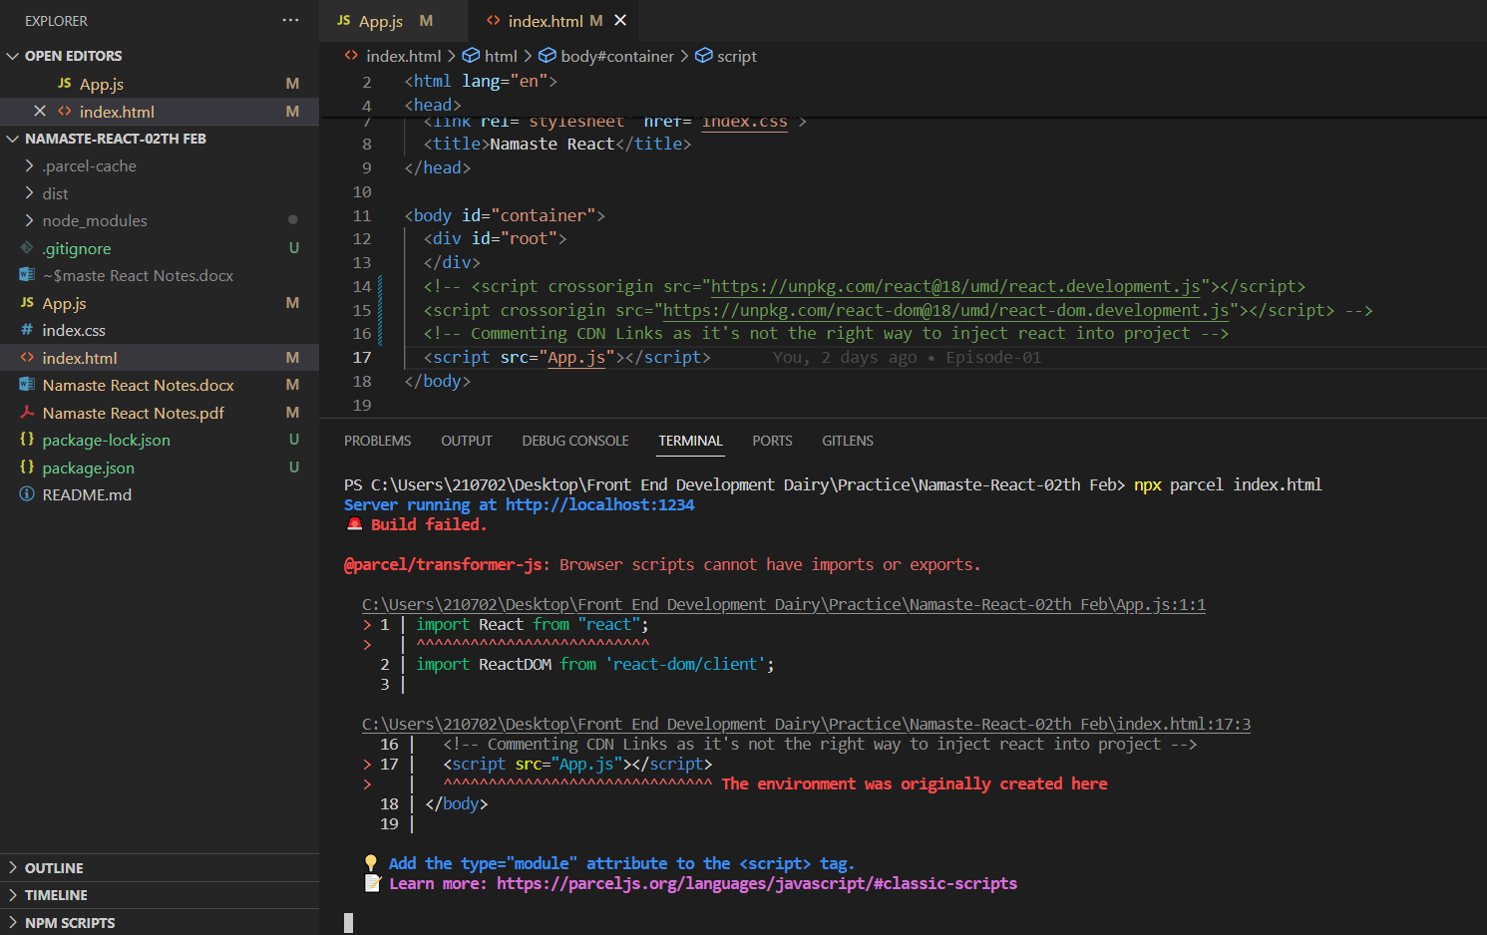

**Error: Browser scripts can’t have imports or exports. Solution would be mention attribute type as module in index.html. As App.js is not a normal file it is a module.**

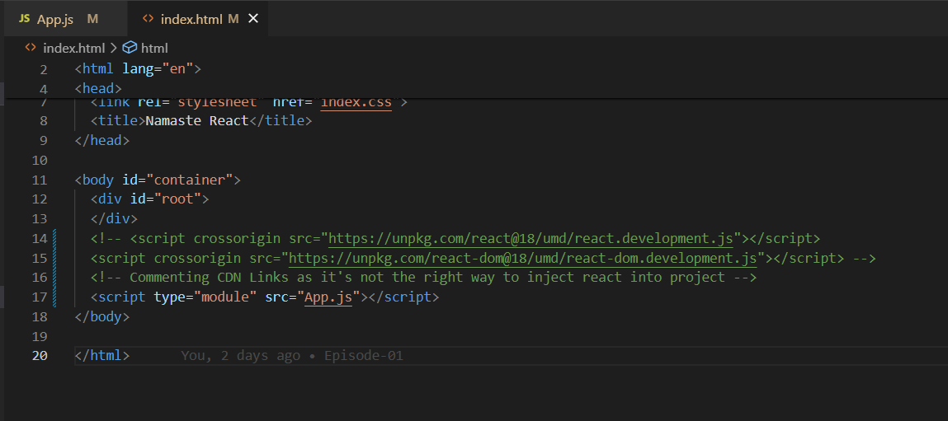

**Error: Expected content key de1e4a02ec63c4eb to exist**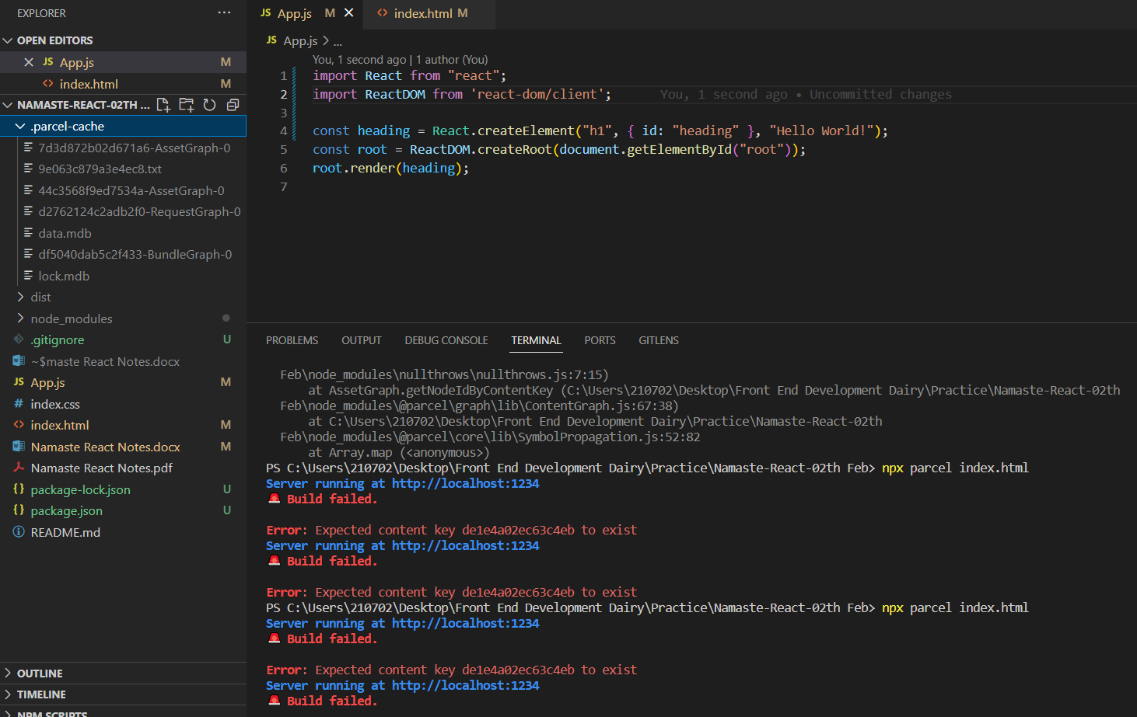

If you are using parcel then try to delete ".parcel-cache" folder. And then Rerun the build to solve the above issue

**What does Parcel do?**

**Read about these concepts in this page (1st page itself).**

<https://parceljs.org/>

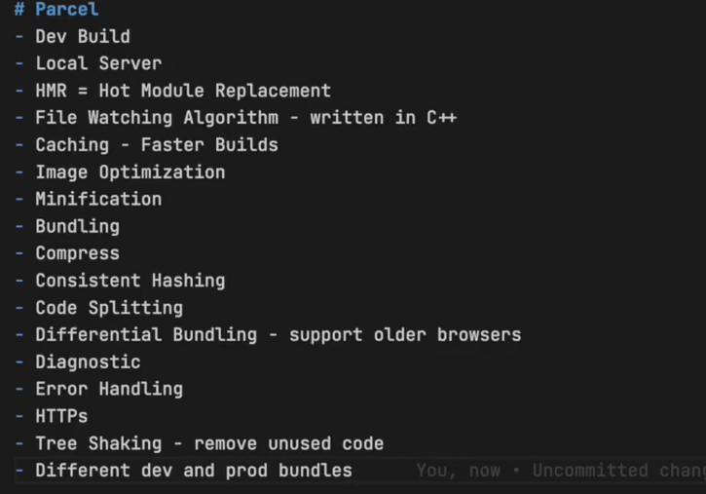

**Read about few of the definitions from below link**

<https://legacy.reactjs.org/docs/code-splitting.html>

Differential bundling is the concept of sending various copies of your code to different targets and letting the browser decide which one to download

**How to create dev build?**

**Code: npx parcel index.html** (“Notice the keyword build missing”)

**How to create production ready build?**

**Code: npx parcel build index.html**

When you run this, the production build gets created in dist folder after all the optimization (Done by parcel).

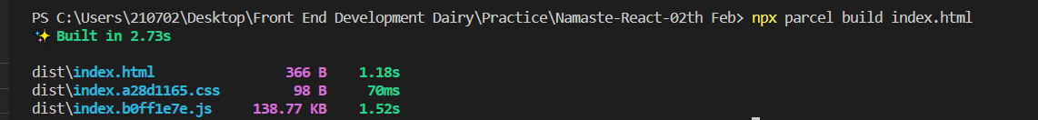

**Error: @parcel/namer-default: Target "main" declares an output file path of "App.js" which does not match the compiled bundle type "html".**

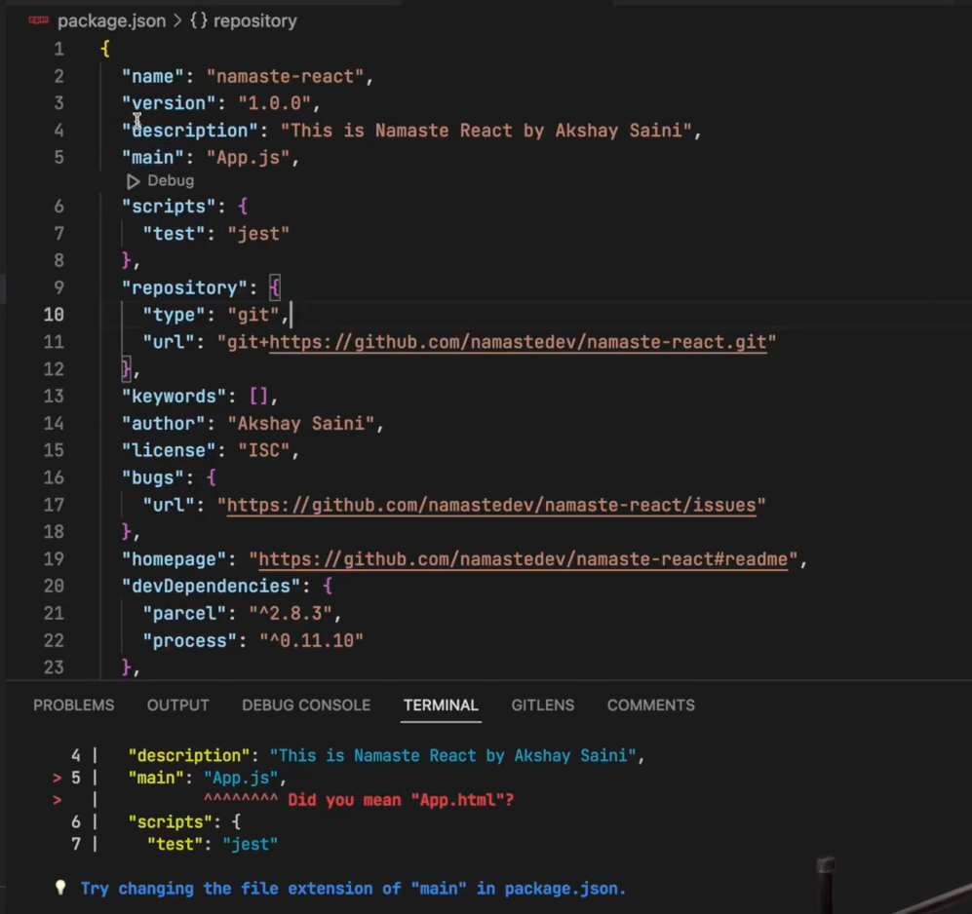

**To solve this error remove “main” in package.json**

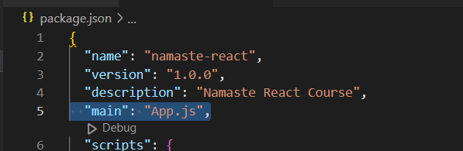

**Like this**

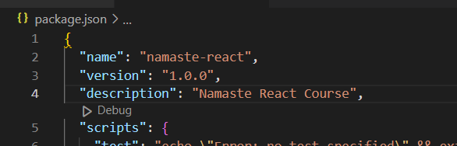

**Flow of Application:**

Server fetches package.json & packge-lock.json from Git and executes the command to create production build. And hosts that build to the end user

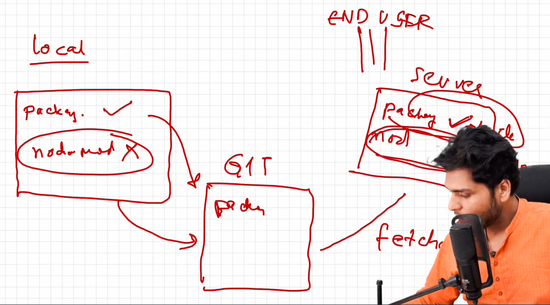

**How to make your app compatible to older versions of browser?**

Use browserlist package for achieving compatibility.

<https://browserslist.dev/?q=bGFzdCAyIHZlcnNpb25z>

<https://github.com/browserslist/browserslist#query-composition>

Configuration is as follows:

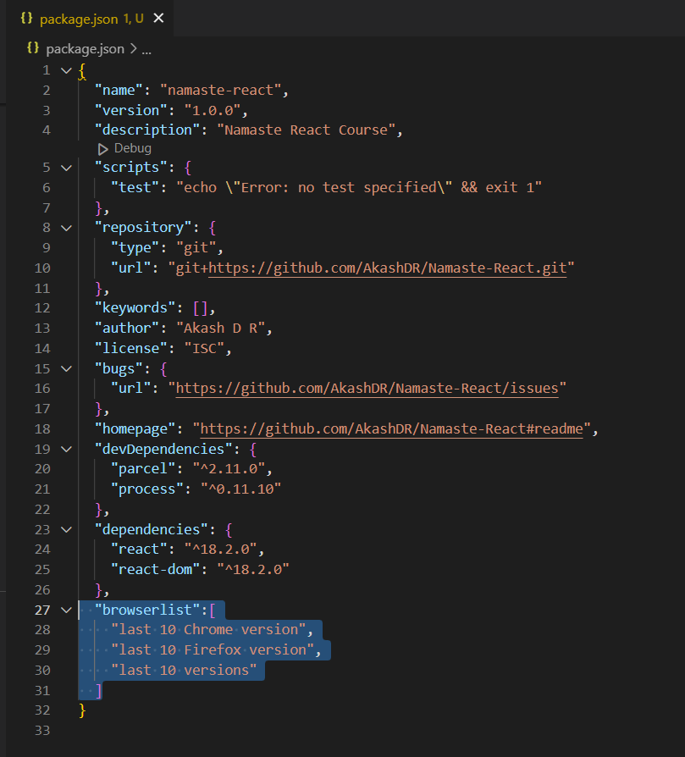

**Promises**: How to extract data from Promises?

const cart = ["Shoes", "Pants", "Watches"];

function createOrder(cart, proceedToPayment) {

  console.log("Order Created", cart);

  console.log("Lets Wait");

  setTimeout(() => {

    proceedToPayment();

  }, 5000);

}

function proceedToPayment() {

  console.log("Proceeded to Payment");

}

createOrder(cart, proceedToPayment);

const URL1 = "https://api.github.com/users/mojombo";

fetch(URL1)

.then((res) => {

  return res?.json();

})

.then((data) => {

  console.log(data, "data");

});

let promise = new Promise((resolve, reject) => {

  reject("Hello JavaScript Failed!");

  });

  promise.then((result) => console.log(result)).catch(

    res=>{

      console.log(res)

    }

  );

const URL2 = "https://api.github.com/users/mojombo";

const user = fetch(URL2)

  .then((res) => {

    return res?.json();

  })

  .then((data) => {

    console.log(data, "data");

  });

**Check the state of Promise**

function createOrder(cart) {

  const promise = new Promise((resolve, reject) => {

    setTimeout(() => {

      resolve("12345");

      console.log(promise, "promise2");

    }, 5000);

  });

  console.log(promise, "promise1");

  return promise;

}

createOrder(cart)

  .then((res) => {

    console.log(res, "res");

  })

  .catch((err) => {

    console.log(err, "err");

  });

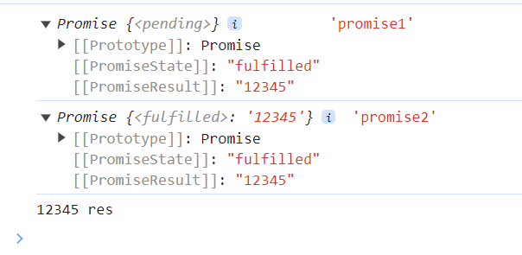

**Usage of finally in Promises.**

function createOrder(cart) {

  const promise = new Promise((resolve, reject) => {

    setTimeout(() => {

      resolve("12345");

      console.log(promise, "promise2");

    }, 5000);

  });

  console.log(promise, "promise1");

  return promise;

}

createOrder(cart)

  .then((res) => {

    console.log(res, "res");

  })

  .catch((err) => {

    console.log(err, "err");

  }).finally(err=>{

    console.log("Just Print - No Matter What")

  });

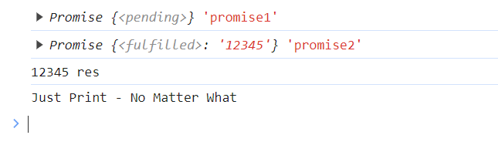

**Promise Chaining:**

Notice the word return inside then block. You should always return if you want to create Promise chain. Else it would lead to Pyramid kind of structure similar to Callback hell.

const cart = ["shoes", "pants", "kurtas"];

function createOrder(cart) {

  return new Promise((resolve, reject) => {

    resolve("Cart Creation Successful");

  });

}

function proceedToPayment(orderId) {

  return new Promise((resolve, reject) => {

    resolve("Payment Successful");

  });

}

createOrder(cart)

  .then((res) => {

    console.log(res);

    return res;

  })

  .then((res) => {

    console.log(res);

    return proceedToPayment(res);

  })

  .then((res) => {

    console.log(res);

    return proceedToPayment(res);

  })

  .then((res) => {

    console.log(res);

    return proceedToPayment(res);

  })

  .then((res) => {

    console.log(res);

  })

  .catch((err) => {

    console.log(err, "err");

  });

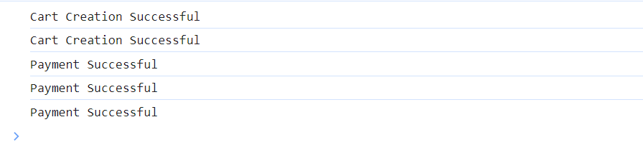

Catch checks only the errors that come above it. It won’t check below it. If we cart creation is failed, we can still move to payment. See Details below.

const cart = ["shoes", "pants", "kurtas"];

function createOrder(cart) {

  return new Promise((resolve, reject) => {

    reject("Cart Creation Failed");

  });

}

function proceedToPayment(orderId) {

  return new Promise((resolve, reject) => {

    resolve("Payment Successful");

  });

}

createOrder(cart)

  .then((res) => {

    console.log(res);

    return res;

  })

  .catch((err) => {

    console.log(err);

    return err

  })

  .then((res) => {

    console.log(res);

    return proceedToPayment(res);

  })

  .then((res) => {

    console.log(res);

    return proceedToPayment(res);

  })

  .catch((err) => {

    console.log(err, "err");

  });

Notice first Catch Block above. It catches only failures in Create Cart Function

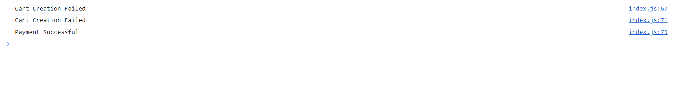

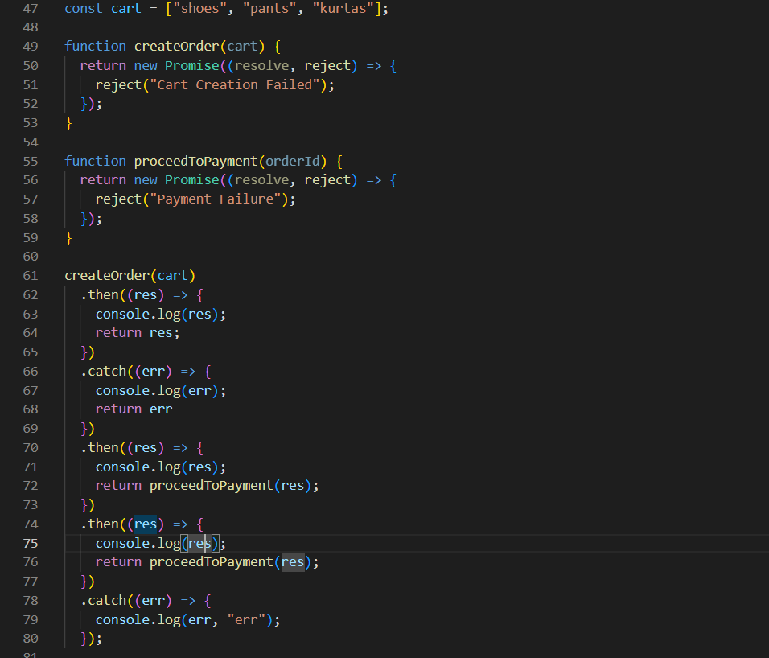

Notice now, the Promise failed at both places, but first catch block catched only Cart Failure error.



**Async & Await**

**Syntax for Async function**

async function getData() {

  return "Namaste Javascript";

}

const data = getData();

console.log(data, "data");

Async function always returns a Promise. If you return any value like string or anything, it will wrap the values inside a Promise and return it.



**Extracting data out of Promise**

async function getData() {

  return "Namaste Javascript";

}

const data = getData();

console.log(data, "data");

data

  .then((response) => {

    console.log(response, "response");

  })

  .catch((err) => {

    console.log(err);

  });



**Example when returning a Promise**

async function getData() {

  const p= new Promise((resolve,reject)=>{

    resolve("Hello World")

  })

  return p;

}

const data = getData();

console.log(data, "data");

data

  .then((response) => {

    console.log(response, "response");

  })

  .catch((err) => {

    console.log(err);

  });

**It won’t wrap with another Promise when returning a Promise. It juts returns it.**

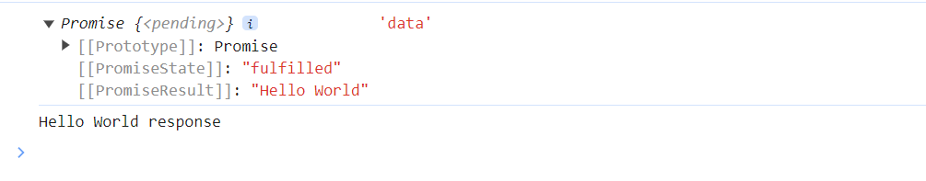

**Using Async and Await together**

const promise = new Promise((resolve, reject) => {

  resolve("Hello World");

});

console.log(promise, "promise");

async function handlePromise() {

  const value = await promise;

  console.log(value, '"value"');

}

handlePromise()

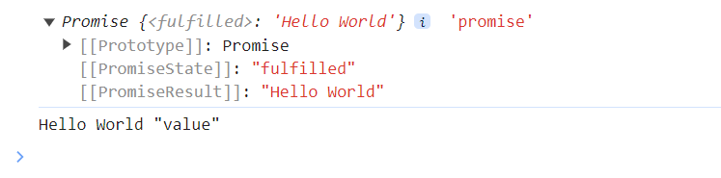

**Await keyword can only be used inside an Async Function. It resolves Promise**

**How Async and Await is different from Normal Promises?**

**What will be printed first (Using Normal Promises)?**

const promise = new Promise((resolve, reject) => {

  setTimeout(() => {

    resolve("Am a Promise");

  }, 10000);

});

function handlePromise() {

  promise.then((res) => {

    console.log(res, "Promise");

  });

  console.log("Namaste JavaScript");

}

handlePromise();



**Using Async and Await to handle Promises**

const promise = new Promise((resolve, reject) => {

  setTimeout(() => {

    resolve("Am a Promise");

  }, 10000);

});

async function handlePromise() {

  // JS Engine waits for Promise to resolve when using Async and Await

  const value = await promise;// Program wait for 10 Sec here

  console.log(value, '"value"');

  console.log("Namaste JavaScript");

}

handlePromise();

**When using await JS Engine waits for Promise to be resolved. But this is not the case when using Normal Promise. Below values will be printed at a time after the timeout of 10 seconds**



const promise = new Promise((resolve, reject) => {

  setTimeout(() => {

    resolve("Am a Promise");

  }, 10000);

});

async function handlePromise() {

  // JS Engine waits for Promise to resolve when using Async and Await

  const value = await promise;// Program wait for 10 Sec here

  console.log(value, '"value"');

  const value2 = await promise;// Program wait for 10 Sec here

  console.log(value2, '"value2"');

  console.log("Namaste JavaScript");

}

handlePromise();

**Here also the whole values will be printed after a gap of 10 seconds (Not 20 Seconds)**

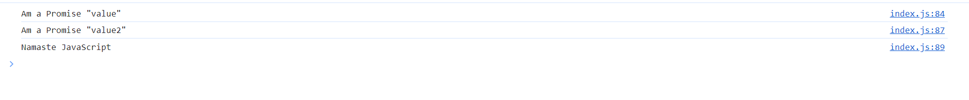

**Even if you create 2 separate Promises like below with different Timeouts. The response will be printed after 10 seconds. At promise1, 10 seconds wait time. At promise2, no wait time because it had only 5s wait time which is already taken place when executing promise1**

const promise = new Promise((resolve, reject) => {

  setTimeout(() => {

    resolve("Am a Promise");

  }, 10000);

});

const promise2 = new Promise((resolve, reject) => {

  setTimeout(() => {

    resolve("Am a Promise 2");

  }, 5000);

});

async function handlePromise() {

  // JS Engine waits for Promise to resolve when using Async and Await

  const value = await promise;// Waits for 10 seconds

  console.log(value, '"value"');

  const value2 = await promise2;// Won’t wait as it has already resolved in first 5 seconds (While waiting for 10 Seconds in first Promise)

  console.log(value2, '"value2"');

  console.log("Namaste JavaScript");

}

handlePromise();



**Reversing the Timeouts. Note the difference. First Promise gets resolved in 5s and then in another 5s the second Promise gets resolved.**

const promise = new Promise((resolve, reject) => {

  setTimeout(() => {

    resolve("Am a Promise");

  }, 5000);

});

const promise2 = new Promise((resolve, reject) => {

  setTimeout(() => {

    resolve("Am a Promise 2");

  }, 10000);

});

async function handlePromise() {

  // JS Engine waits for Promise to resolve when using Async and Await

  const value = await promise;

  console.log(value, '"value"');// Will wait for 5 Seconds

  const value2 = await promise2;

  console.log(value2, '"value2"');//Will wait for another 5 seconds not 10 seconds

  console.log("Namaste JavaScript");

}

handlePromise();



Time, Tide and JavaScript waits for None. JS Engine appears waiting (Only looks like), but it is not actually waiting. If it is waiting, then screen would Freeze.

When it sees await keyword, it actually suspends execution of handlePromise() function. It won’t block the call stack (JS has only one call stack). Once the promise1 is resolved, handlePromise() again comes into action. It will start execution from where it left. Again, it will check for promise 2, as it has **await keyword**. So it would be suspended again. It will move out of call stack. Comes back when promise2 is resolved. It is not JS Engine that is waiting, it is the handle Promise function that gets suspended.

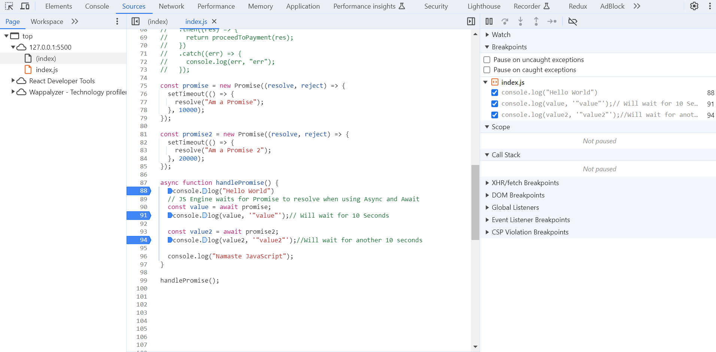

You can notice suspend of handlePromise() function in Call Stack. JS Engine, separately tracks the function.

<https://api.github.com/> Can be used for sample APIs

**How fetch works?**

Fetch Returns a Response Object. Response object has a body which is a readable stream, if you want to convert Readable Stream into a json you have to do **Response.json()**. Response.json() is a promise which must be resolved to get the data.

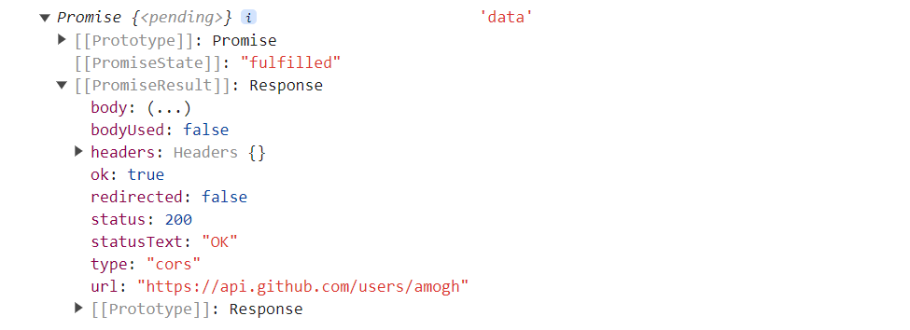

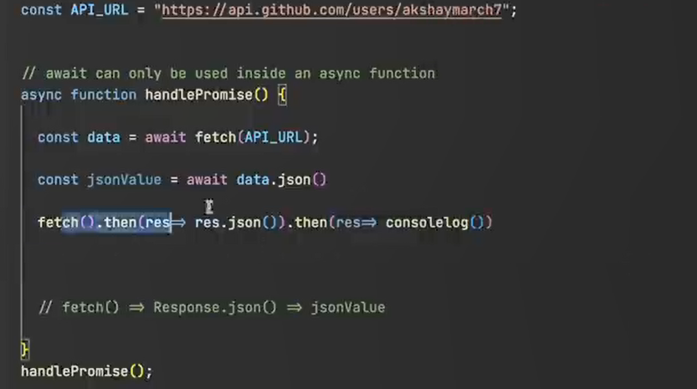

Await gives resolved Promise

async function getData() {

  const data = await fetch("https://api.github.com/users/amogh");

  const userData = await data.json();// Await would give resolved Promise

  console.log(userData,'userData')

}

getData()

You will have data as below

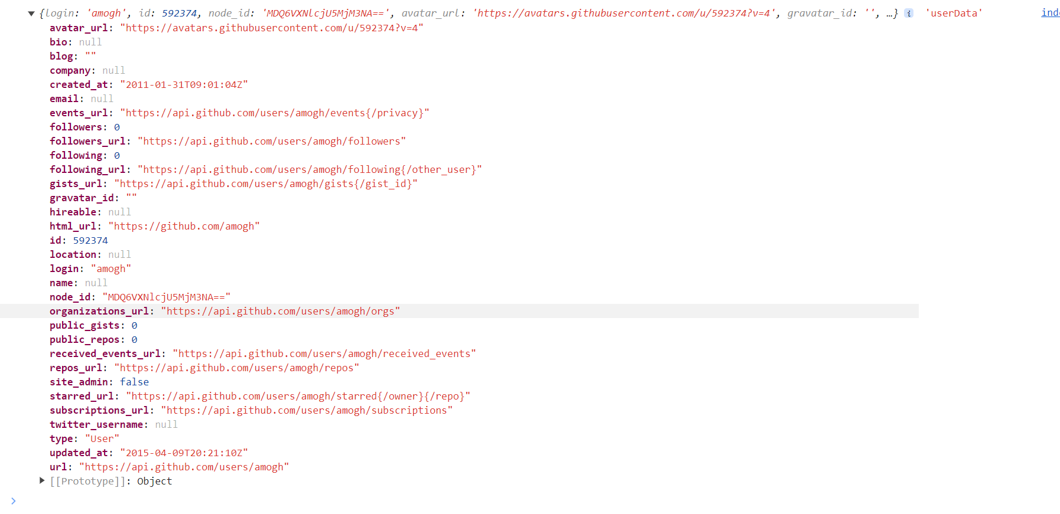

But in case of Promise, you have to resolve separately **using .then**. Notice the difference below

// Using Async and Await

async function getData() {

  const data = await fetch("https://api.github.com/users/amogh");

  const userData = await data.json();// Await would give resolved Promise

  console.log(userData,'userData')

}

getData()

//Using Promise

function getData2() {

  fetch("https://api.github.com/users/amogh")

    .then((res) => {

      return res?.json();

    })

    .then((data) => {

      console.log(data, "data");

    });

}

getData2()

**Error Handling in Async and Await has to be done using try and catch**

// Using Async and Await

const URL = "https://invalidUrl";

async function getData() {

  try {

    const data = await fetch(URL);

    const userData = await data.json();

    console.log(userData, "userData");

  } catch (err){

    console.log(err, "err");

  }

}

getData()

// Using Promise

function getData2() {

  fetch("https://api.github.com/users/amogh")

    .then((res) => {

      return res?.json();

    })

    .then((data) => {

      console.log(data, "data");

    })

    .catch((err) => console.log(err, err));

}

getData2();



**Another way is as follows:**

**As Async function always returns a Promise**

// Using Async and Await

const URL = "https://invalidUrl";

async function getData() {

    const data = await fetch(URL);

    const userData = await data.json();

    console.log(userData, "userData");

}

getData().catch((err) => console.log(err, "err"));

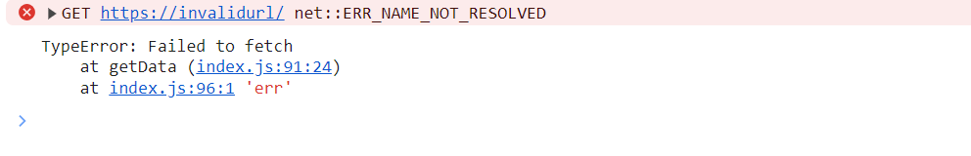

**Aysnc-Await is just syntactical sugar for Promises. Behind the scenes it also uses then and catch. In general, Async-Await solves the complexity of Promise Chaining. It’s always a personal choice which to use.**

**Promise.all**

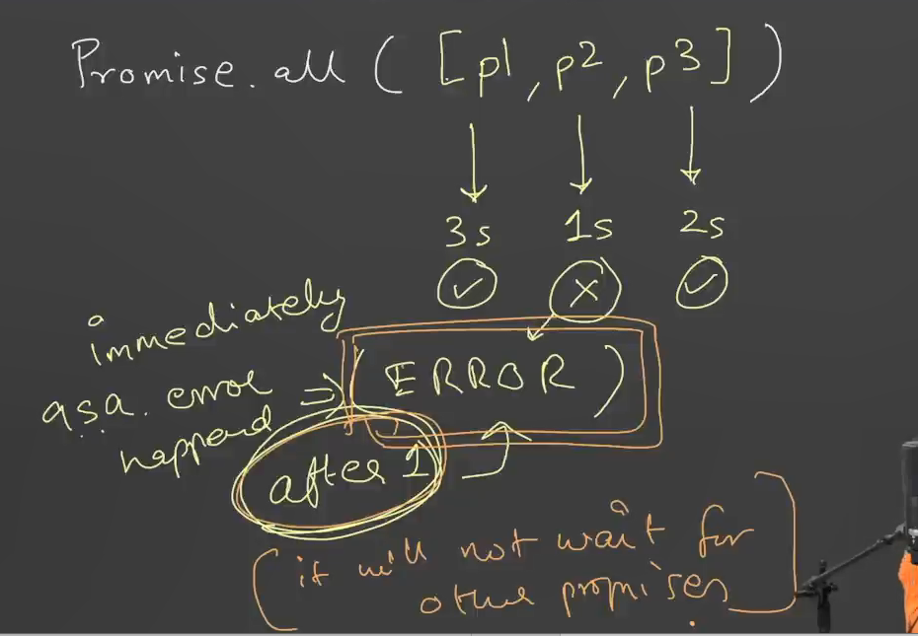

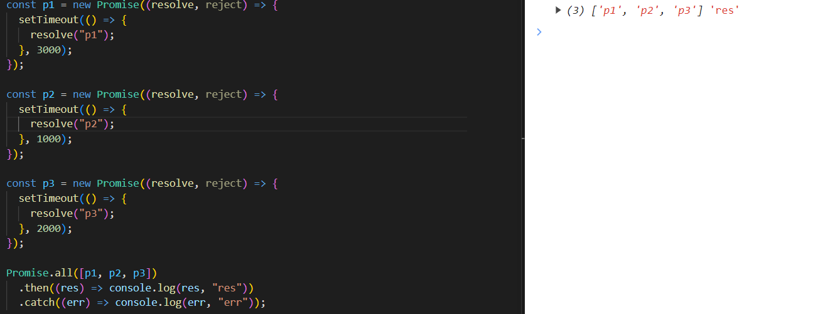

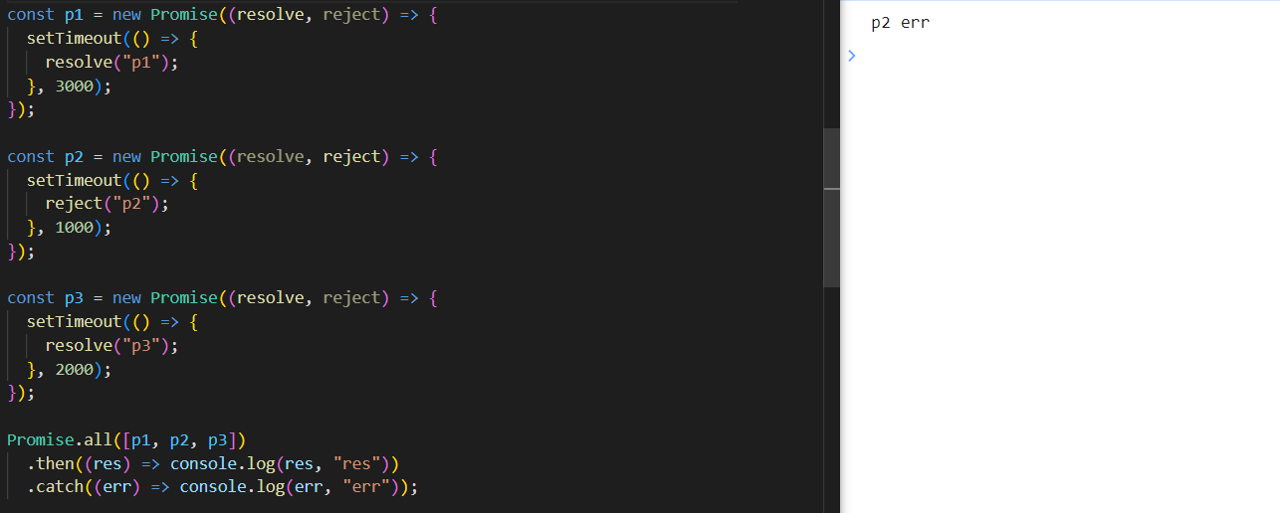

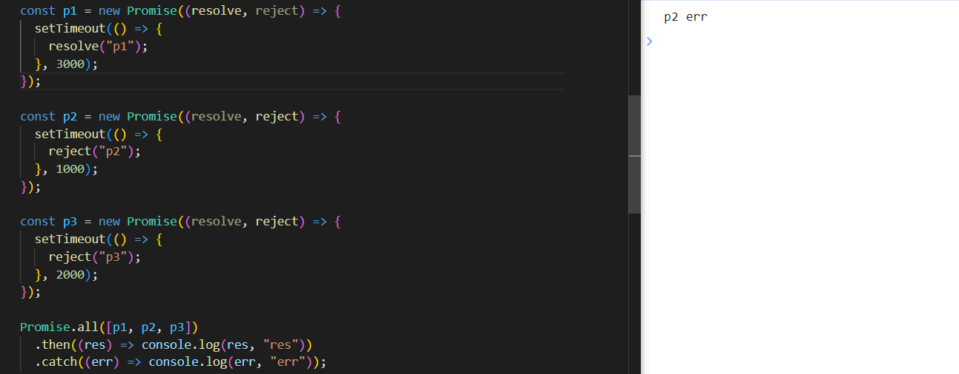

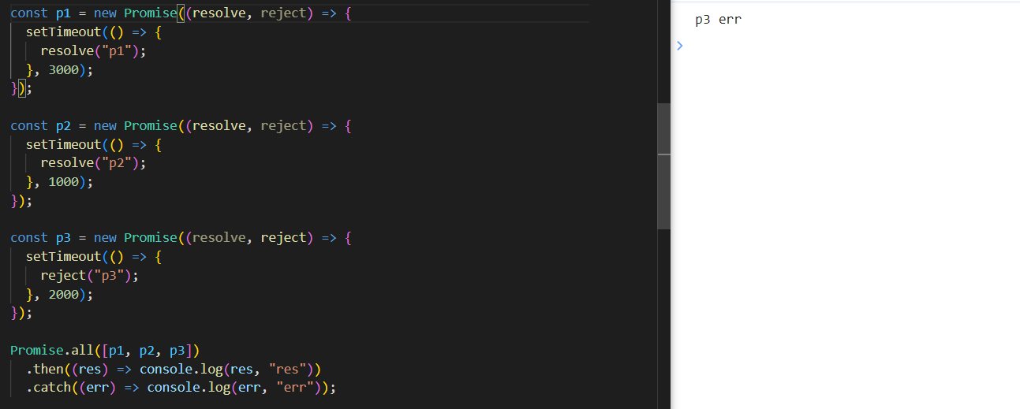

**Promise.allSettled**

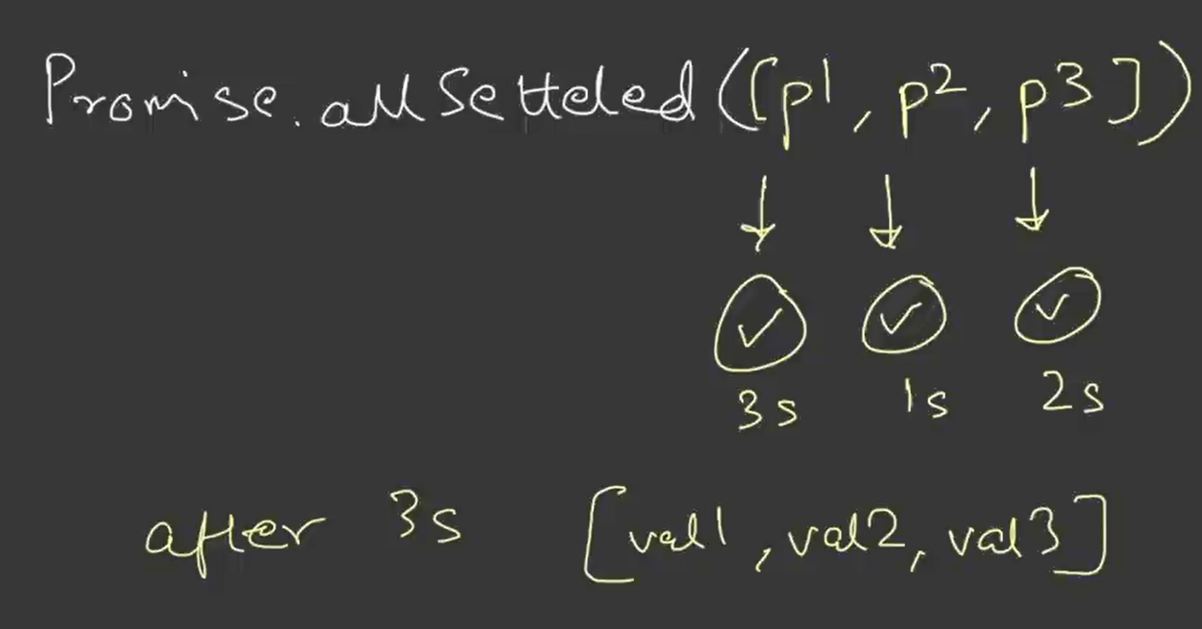

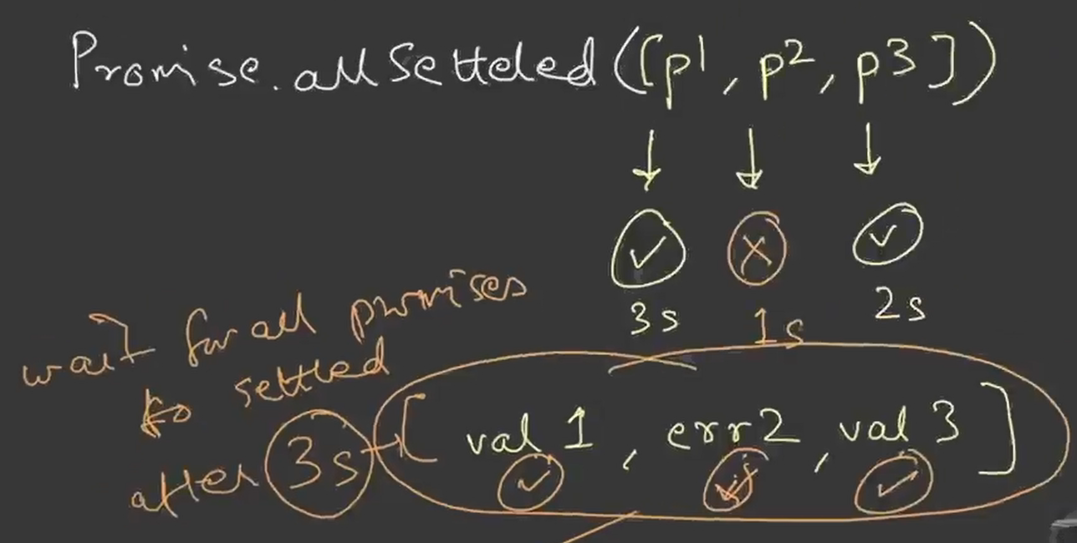

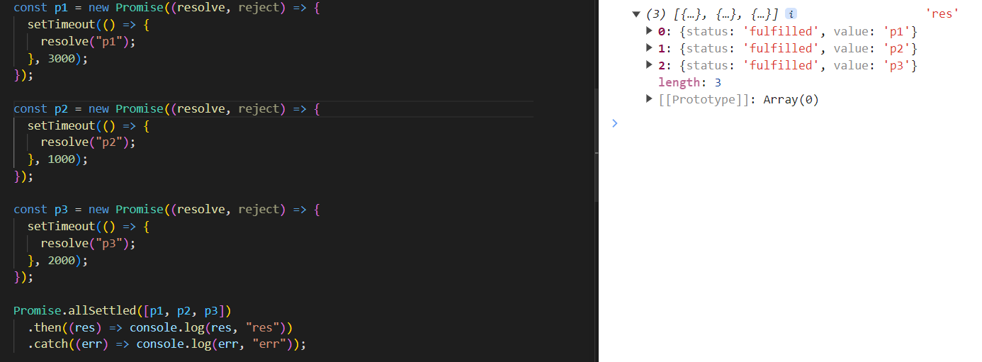

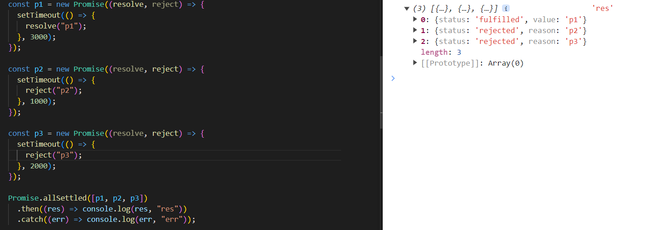

**Promise.race**

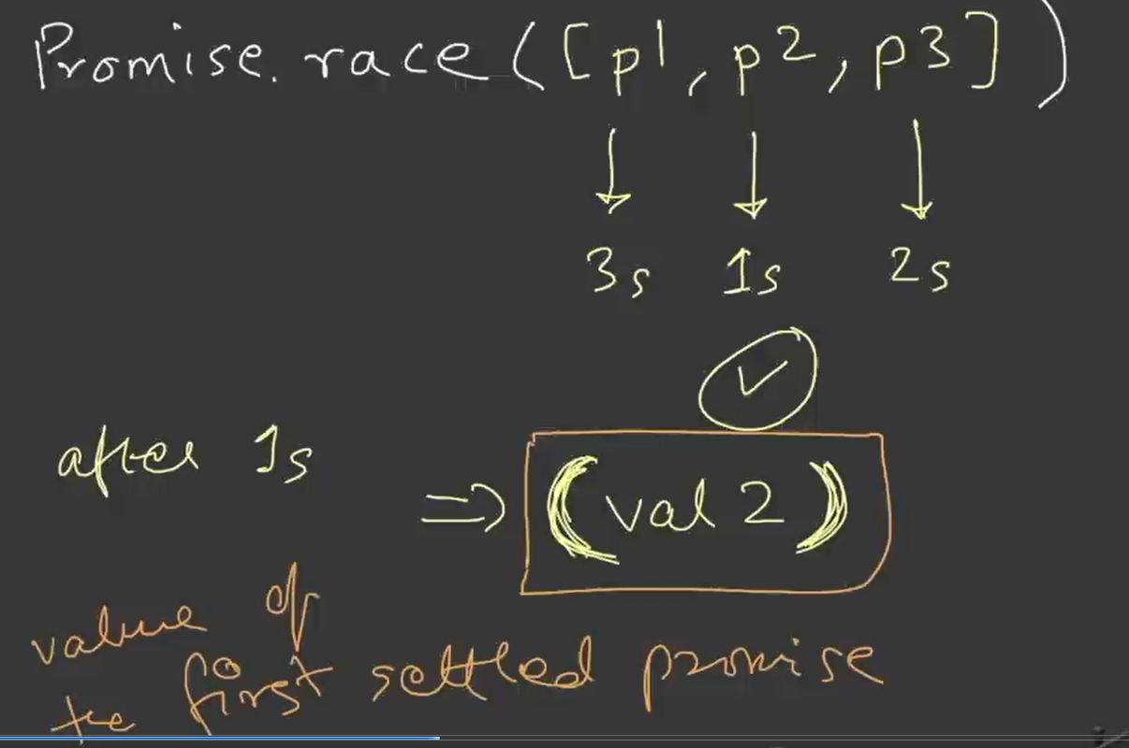

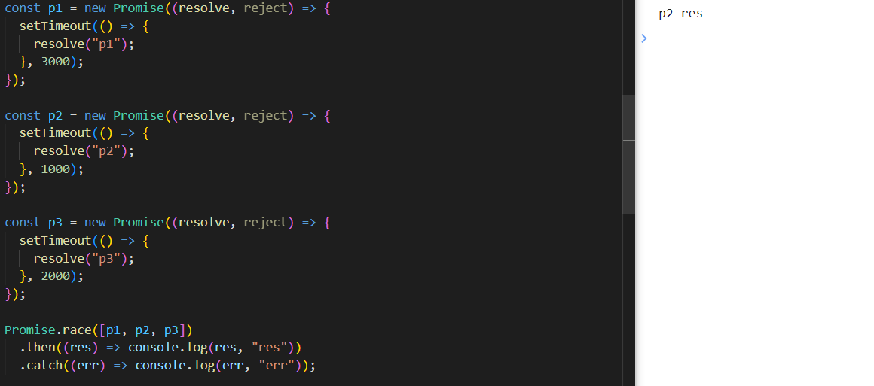

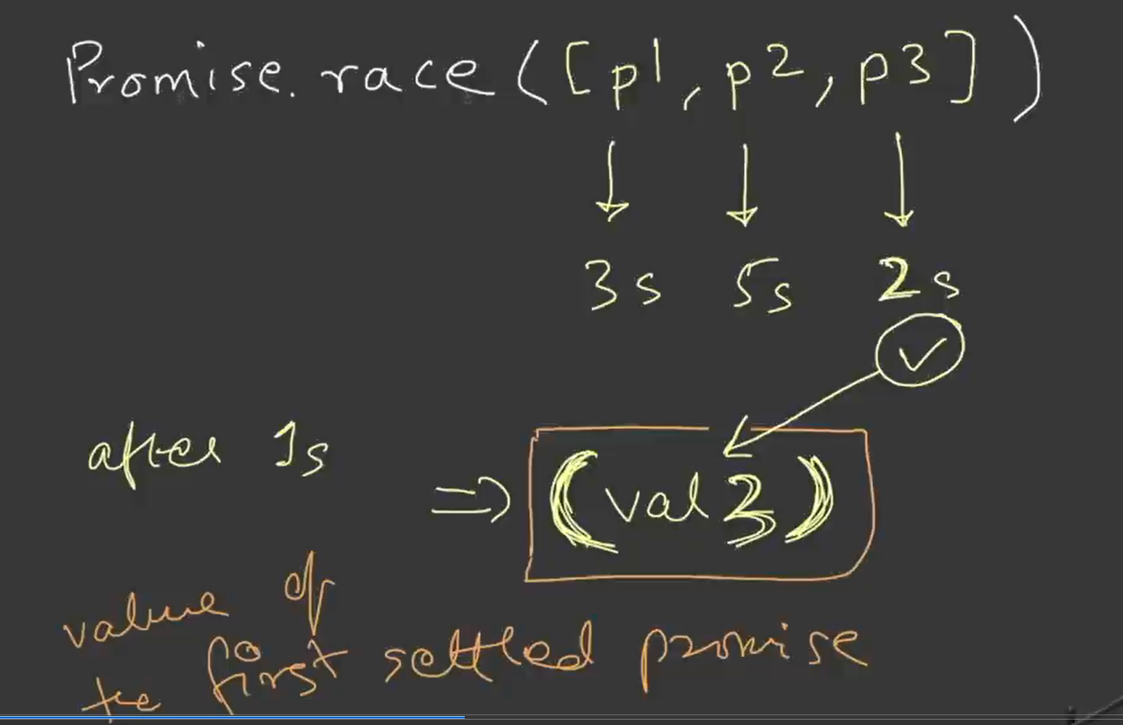

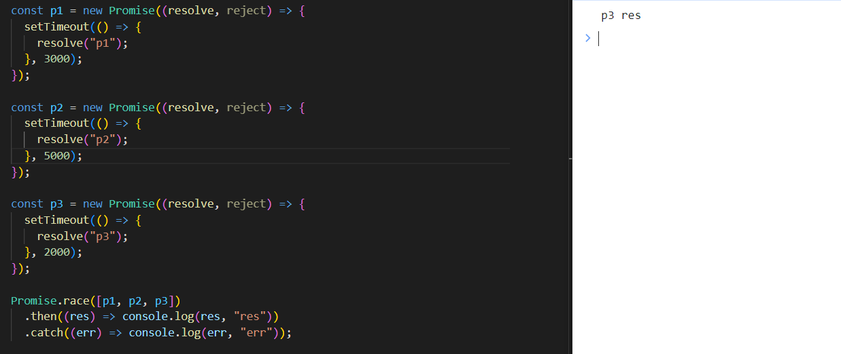

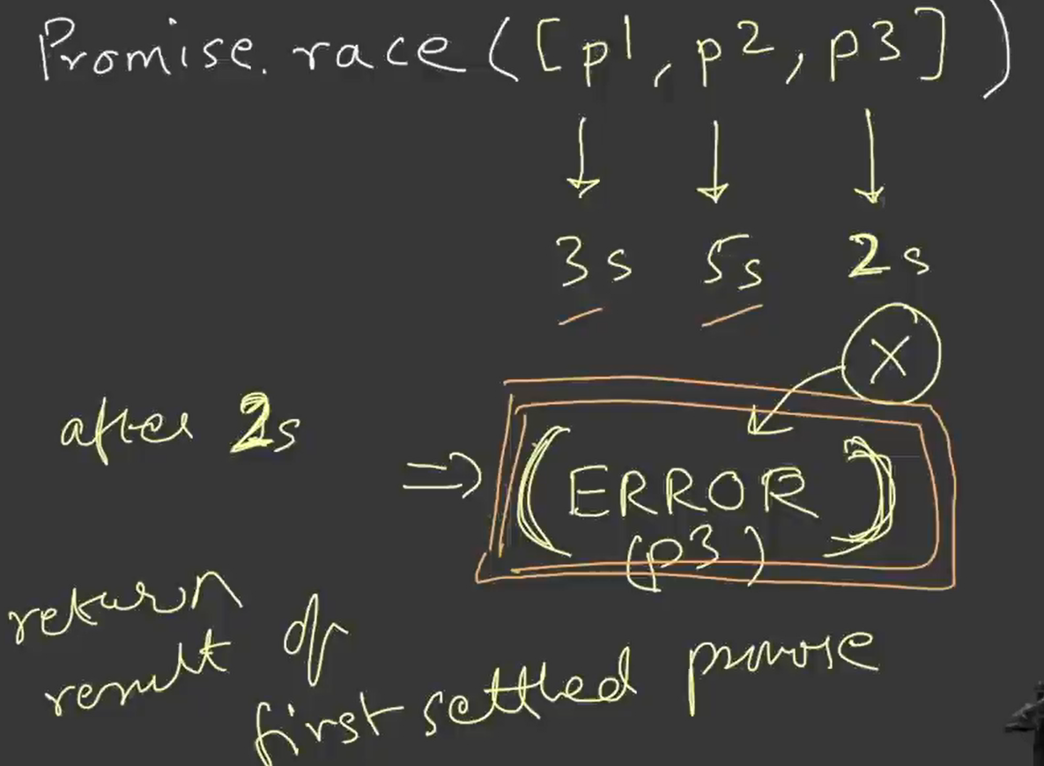

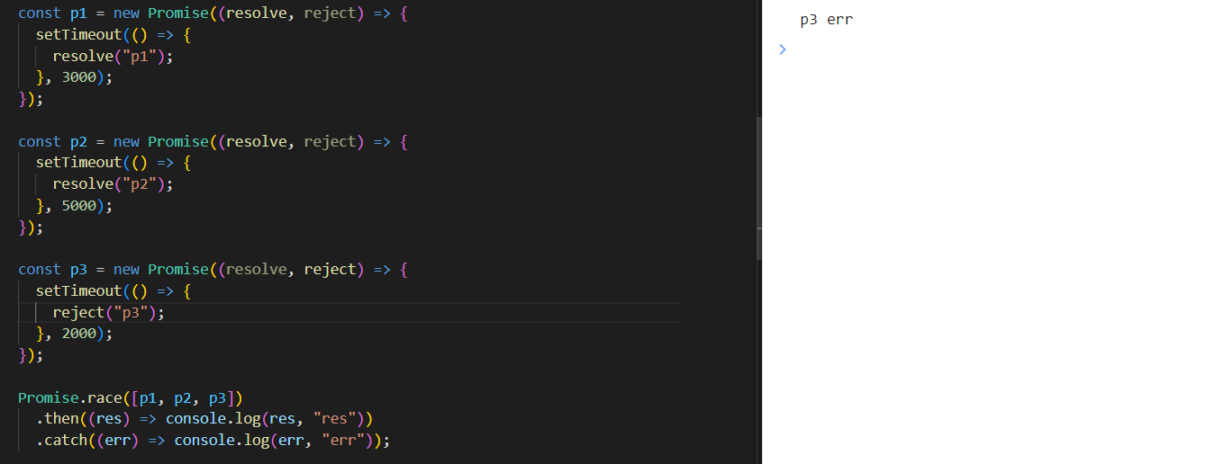

**Promise.any**

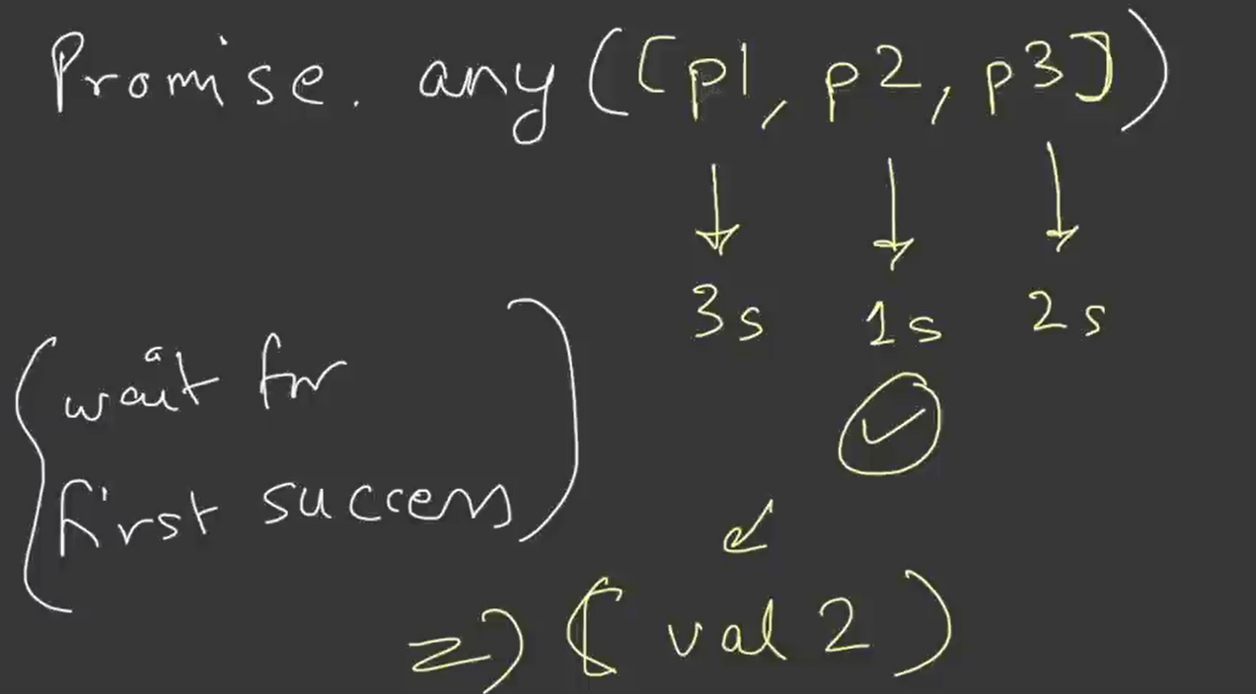

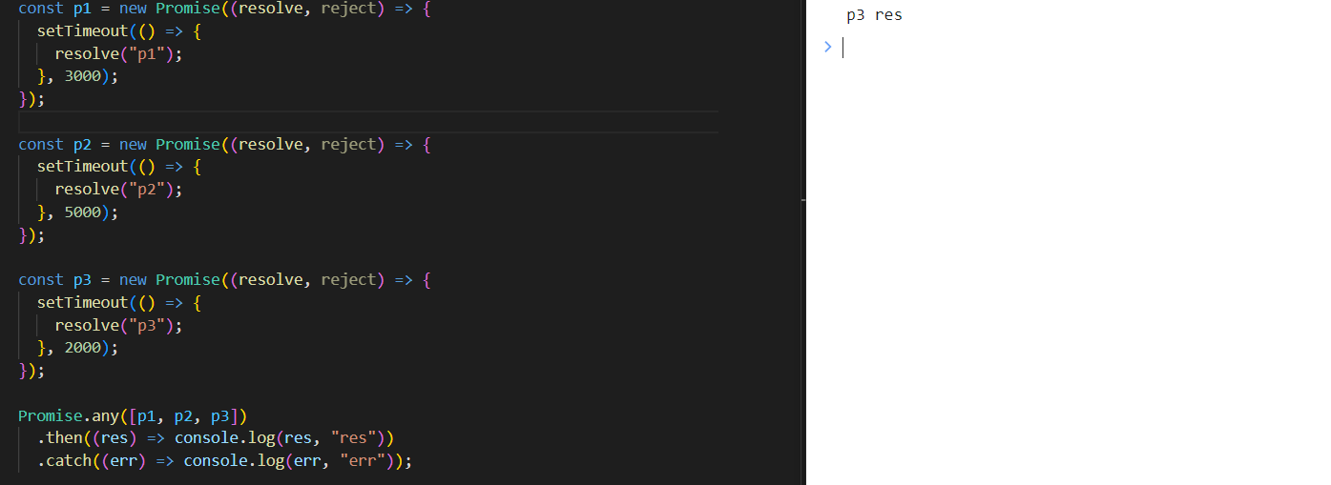

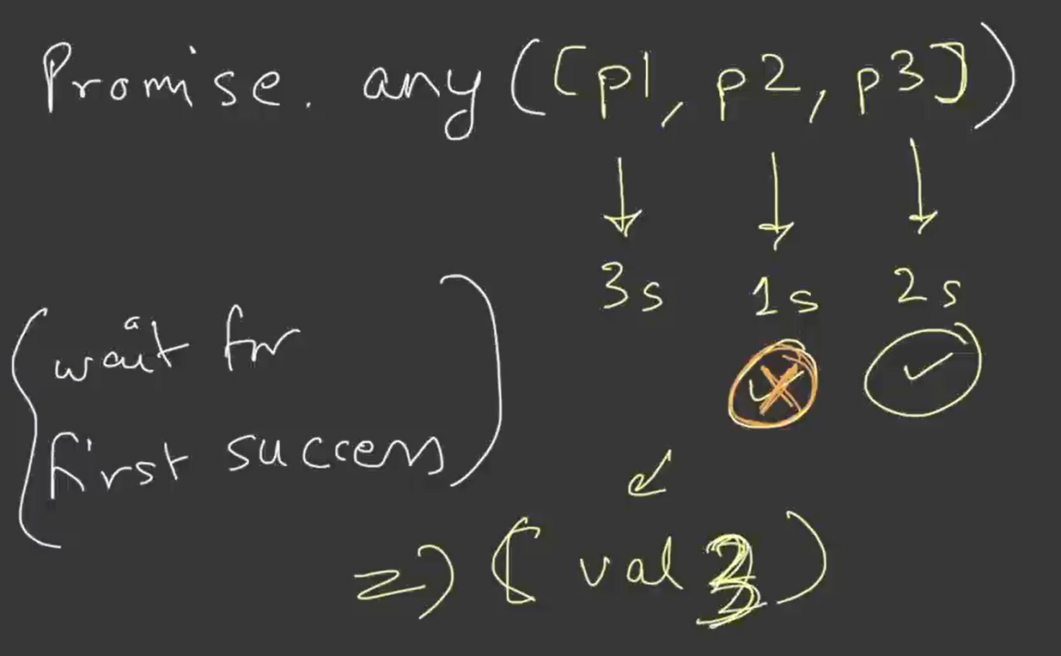

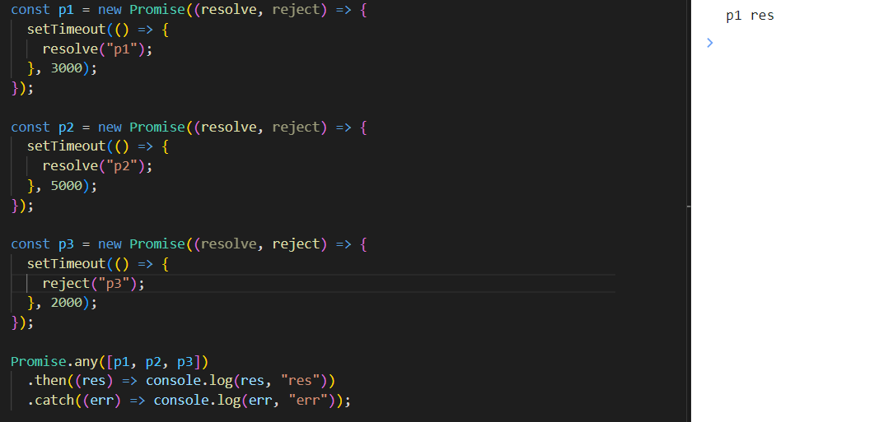

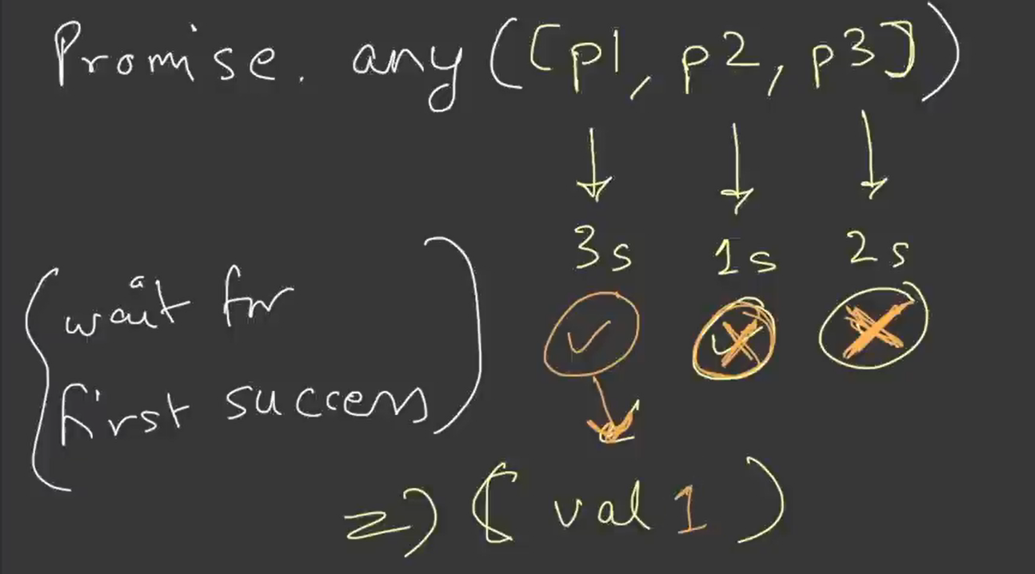

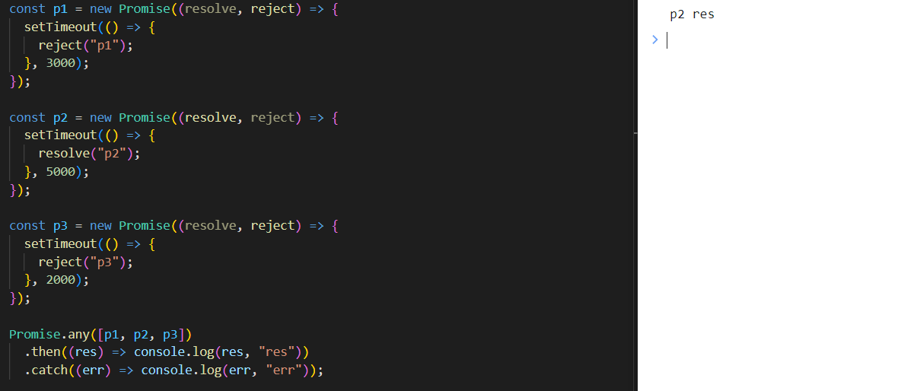

**If all the promises are rejected, then it gives AggregateError**

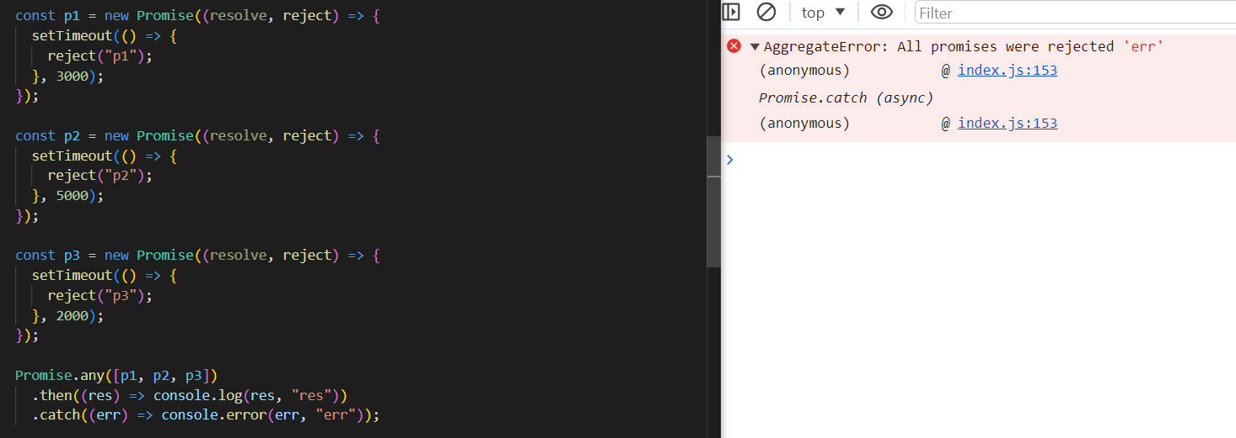

**Handling Aggreagte Error (You have to use err.error)**

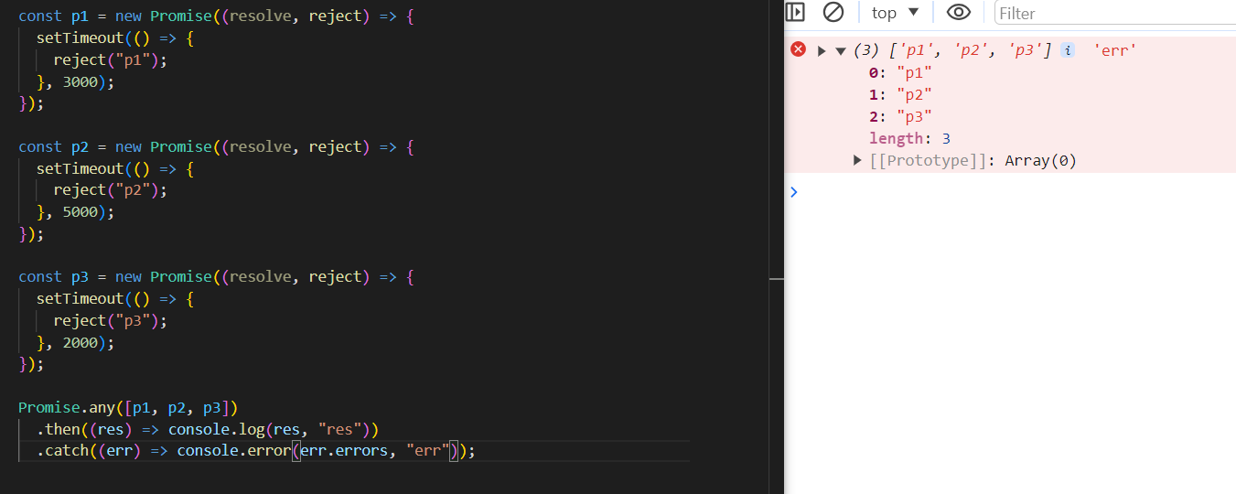

**Lecture-03 Laying the Foundation**